CHAPTER 1 INTRODUCTION

**In the digital age, the rapid growth of technology and the internet has brought numerous benefits to society, facilitating communication, commerce, and information sharing. However, with these advancements also come various cybersecurity challenges, one of the most prominent being the rise of phishing attacks. The digital landscape, while offering immense opportunities, also harbors insidious threats like phishing attacks.** These meticulously crafted scams mimic legitimate websites to deceive users into divulging sensitive information, causing significant financial and reputational damage to individuals and organizations alike. Conventional detection methods, often static and rule-based, struggle to keep pace with the ever-evolving nature of phishing tactics. **This project presents a groundbreaking solution leveraging the power of machine learning (ML) algorithms for accurate and real-time detection of phishing websites.** We move beyond simplistic blacklists and static rules, instead, **capitalizing on a rich tapestry of environmental impact factors** associated with these deceptive attempts.Our approach analyzes a diverse range of features including:

* URL structure: Identifying suspicious patterns in domain names and paths.
* SSL certificates: Assessing their legitimacy and validity.
* Domain age: Recognizing newly registered domains, a common phishing tactic.
* User behavior: Detecting anomalous interactions and navigation patterns.
* Content analysis: Examining text and visual elements for inconsistencies and red flags.

This project, "Phishing Website Detection Using ML Algorithms," is driven by the imperative to fortify cyber defenses by leveraging the capabilities of machine learning (ML). The overarching goal is to develop a robust system that can autonomously identify and mitigate the risks associated with phishing websites. The urgency of this endeavor is underscored by the potential consequences of falling victim to phishing, ranging from financial losses to the compromise of personal and confidential data.



**Fig-1.1 Fake URLs**

By holistically considering these factors, our ML model paints a comprehensive picture of the online environment, enabling continuous learning from emerging threats and evolving phisher tactics. We don't merely react to existing patterns; we proactively anticipate and identify suspicious behavior in real-time.

This project's significance transcends immediate accuracy. Our scalable architecture adapts to the ever-growing volume of online content, making it a future-proof solution in the face of an expanding digital threat landscape. In essence, this project offers a paradigm shift in phishing website detection. By integrating advanced ML algorithms with a holistic understanding of environmental factors, we provide a proactive, adaptive, and accurate defense against these sophisticated online scams. We pave the way for a safer and more secure digital future for all.

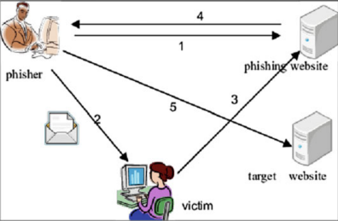

**Fig 1.2-Image showing the Phishing process**

Phishing site detection is considered a binary classification task with two-class predictions: malicious and benign. The training of the ML method consists of finding the best mapping between the d-dimensional vector space and the output variable. This strategy has a strong generalization capacity to find unknown malicious URLs compared to the blacklist approach.

Recurrent Neural Network (RNN), Long Short-Term Memory (LSTM) is one of the ML techniques that presents a solution for complex real-time problems. LSTM allows RNN to store inputs for a longer period. It is similar to the concept of storage in computers. In addition, each feature will be processed according to the uniform distribution. The combination of RNN and LSTM enables to extraction of a lot of information from a minimum set of data. Therefore, it supports a phishing detection system to identify a malicious site in a shorter duration.

In this context, the project seeks to harness the power of ML algorithms to proactively detect and classify phishing websites. This introduction sets the stage by acknowledging the gravity of the phishing threat, establishing the relevance of the research, and highlighting the need for advanced technological solutions. The subsequent chapters will delve into the methodologies employed, the intricacies of ML algorithm selection, data collection and analysis, and the envisioned impact of the developed system on enhancing overall cybersecurity measures. As the digital landscape continues to evolve, this project endeavors to contribute to the collective efforts aimed at creating a safer online environment for users worldwide. This introduction sets the stage by acknowledging the gravity of the phishing threat, establishing the relevance of the research, and highlighting the need for advanced technological solutions. The subsequent chapters will delve into the methodologies employed, the intricacies of ML algorithm selection, data collection and analysis, and the envisioned impact of the developed system on enhancing overall cybersecurity measures.

* 1. PHISHING A GROWING THREAT:

### Definition and Characteristics:

### Phishing is a deceptive online practice where attackers masquerade as legitimate entities (individuals, organizations, or websites) to trick unsuspecting victims into divulging sensitive information such as passwords, credit card details, or personal data. It's a form of social engineering that exploits human trust and vulnerabilities to achieve malicious goals.

1. **Key Characteristics:**

* Deception
* Information Gathering
* Delivery Channels
  1. **MAchine learning in cybersecurty**

Cybersecurity has become increasingly crucial in today's digital world, with threats evolving at a rapid pace. Traditional methods of defense, like static rules and signature-based detection, often struggle to keep up. This is where machine learning (ML) steps in as a game-changer for threat detection.

**The Role of ML in Threat Detection:**

* **Anomaly Detection**
* **Predictive Analytics**
* **Automated Threat Hunting**
* **Improved Threat Intelligence**

*1.1.2.* *Impact on Individuals and Organizations:*

Phishing attacks, like intricate digital fishing nets, aim to ensnare unsuspecting victims and steal their valuable information. These malicious scams can have dire consequences for both individuals and organizations, causing financial losses, data breaches, and reputational damage.

1. **figures and Tables**

Center Align all the figures. Caption should appear at the bottom of the Fig. To give the caption, right-click the figure and choose figure caption with numbering as <chap No.>.<fig number>

Figure 1.1 A sample Figure

Table 1.1: A sample table

|  |  |  |  |
| --- | --- | --- | --- |
| **Sl.No.** | **This is a** | **Sample** | **Table** |
| 1 | ITEM 1 | SAMPLE1 | SOMETHING |
| 2 | ITEM2 | ANOTHER SAMPLE LINE SPREADING OVER | SOMETHING |

Center Align all the Tables. Caption should appear at the top of the table. To give the caption, right click the table and choose caption with numbering as <chap No.>.<fig number>

1. **Scope**

This project aims to develop an accurate and real-time ML-powered system for detecting phishing websites, going beyond static rules to analyze a diverse range of environmental factors like URL structure, user behaviour, and content. Its scope encompasses data collection and feature extraction from labelled websites, training and evaluation of various ML algorithms like SVMs and Random Forests, and ensuring scalability and adaptability to handle the ever-growing web and evolving phishing tactics. This innovative approach has a significant social and environmental impact, promising a safer digital landscape by:

* Reducing phishing scams: Protecting individuals and organizations from financial losses, data breaches, and eroded trust in online interactions.
* Enhancing cybersecurity: Contributing to more advanced threat detection solutions, lowering cyberattack risks for all, and fostering research in AI and cybersecurity.

By addressing data bias and user education alongside technological advancements, this project holds the potential to make a substantial impact on online security.

**CHAPTER 2 PROBLEM DEFINITION**

Phishing attacks continue to pose a significant threat to individuals and organizations alike. These attacks involve malicious actors creating deceptive websites that mimic legitimate ones, aiming to steal sensitive information such as login credentials, financial details, or personal data from unsuspecting users. Traditional rule–based and signature–based methods struggle to keep up with evolving tactics of phishers, leading to a pressing need for more effective detection mechanisms. The specific problem addressed by this project is the need for a proactive and adaptive solution to detect phishing websites using machine learning (ML) algorithms. Traditional methods of identifying phishing sites are often rule-based and struggle to keep up with the dynamic nature of cyber threats. The challenge lies in developing a system that can autonomously analyze website features and user behavior patterns to distinguish between legitimate and malicious entities.

**Problem Statement:**

Ramu is an Engineering Student who always wants to research new things. To do that he always searches for the information he wants on the internet. During that time sometimes he is followed through the phishing websites which leads to valuable data loss.

**User:**

Phishing attacks continue to pose a significant threat to individuals and organizations alike. These attacks involve malicious actors creating deceptive websites that mimic legitimate ones, aiming to steal sensitive information such as login credentials, financial details, or personal data from unsuspecting users. Traditional rule-based and signature-based methods struggle to keep up with the evolving tactics of phishers, leadingto a pressing need for more effectivedetection mechanisms**.**

**CHAPTER 3 LITERATURE REVIEW**

**PAPER1:** **URL-Based Detection Using Gradient And Catboost Classifier**

Here is a draft literature review on phishing website detection using machine learning:

Phishing is a type of cybercrime that aims to steal sensitive user information such as login credentials and financial details by creating fake websites that impersonate legitimate ones. As phishing attacks are becoming more sophisticated, traditional blacklist-based approaches are unable to provide sufficient protection. This has led to growing research interest in using machine learning techniques for detecting phishing websites automatically based on website features.

Several studies have explored using machine learning for phishing website detection. Mohammad et al. (2014) proposed using a self-structuring neural network which achieved 95% accuracy in classifying phishing websites. Altyeb Taha (2021) developed an ensemble model based on weighted soft voting that combines multiple weak classifier models to improve performance. The model obtained 98% accuracy. Sahoo et al. (2017) provided a comprehensive survey of different machine learning techniques like SVM, neural networks, etc. that have been used for malicious website detection.

Maini et al. (2021) compared eight machine learning algorithms - Random Forest, Decision Tree, Naive Bayes, AdaBoost, KNN, XGBoost, SVM, and Logistic Regression on a phishing URL dataset. The ensemble model built using these algorithms achieved better accuracy than individual models, with XGBoost having the best individual performance. Bentéjac et al. (2021) analyzed different gradient boosting algorithms like XGBoost, LightGBM and CatBoost for detecting phishing websites based on URL and website content features.

**Key Techniques**

Some of the major machine learning techniques used for phishing detection include:

Ensemble learning: Combines multiple weak learner models like decision trees to create a stronger classifier (Altyeb Taha, 2021; Maini et al., 2021)

**Gradient boosting**: Builds models sequentially to reduce errors. CatBoost has shown good results (Bentéjac et al., 2021)

**Deep learning**: Neural network models that can learn complex website feature relationships (Mohammad et al., 2014)

**Tree-based models**: Random forest, and XGBoost have provided high accuracy for phishing detection (Maini et al., 2021)

**Evaluation Metrics**

The key evaluation metrics used across studies for comparing phishing detection models are:

* Accuracy
* Precision
* Recall
* F1-score

Models are also analyzed based on false positive and false negative rates. Lower false negative rates are critical to reduce instances of phishing websites going undetected.

**Conclusion**

The review shows that machine learning models can automatically detect phishing websites with high accuracy by learning from features like URLs, domain registrar details, page content, etc. Ensemble models and gradient boosting techniques appear particularly promising. Focus on improving recall and reducing false negatives is important for deployment. There is further scope to explore deep learning and transfer learning approaches.

**PAPER 2: Phishing URLs**

Here is a draft literature review on phishing website detection using machine learning based on the provided paper:

Phishing is a prevalent cyber threat where attackers create fake websites impersonating legitimate ones to steal sensitive user information. As phishing attacks are becoming more advanced, traditional blacklisting approaches are unable to provide adequate protection. This has driven significant research interest in applying machine learning techniques for automatic phishing website detection based on website features.

Several studies have explored machine learning models for phishing detection. Mohammad et al. (2014) developed a self-structuring neural network model achieving 95% accuracy on a phishing website dataset. Sahoo et al. (2017) provided a comprehensive survey of machine learning techniques including SVM, neural networks etc. used for malicious website detection.

Alarbi et al. (2020) proposed a multilayer perceptron (MLP) model for phishing detection using website content, URL and domain-based features. The Correlation-based Feature Selection method was used to select the most relevant features. With 17 input features, the MLP model obtained 99.1% accuracy using 70% training data. Maini et al. (2021) evaluated eight ML algorithms on a phishing URL dataset and found that an ensemble of these models performed better than individual ones, with XGBoost having highest individual accuracy.

**Key Techniques:**

Some major machine learning techniques explored for phishing detection are:

**Neural networks**: Feedforward, multilayer perceptron networks capturing non-linear website feature relationships (Alarbi et al., 2020; Mohammad et al., 2014)

**Ensemble learning:** Combining multiple weak learner models like decision trees or MLPs (Maini et al., 2021)

**Tree-based models**: Random forest, XGBoost providing high accuracy (Maini et al., 2021)

**Feature selection:** To select most relevant features and reduce overfitting (Alarbi et al., 2020)

The critical evaluation metrics used are accuracy, precision, recall and F1-score. Minimizing false negatives is important for reliable phishing detection.

**Conclusion**

The review demonstrates that machine learning, especially neural networks and ensemble methods can automatically detect phishing websites with high accuracy. Intelligent feature selection and model optimization are important to improve efficiency. There is further potential in exploring deep neural networks and transfer learning approaches.

**PAPER 3: Phishing Website Detection Using Hybrid-SVM and KNN approach**

Here is a draft literature review on phishing website detection using machine learning based on the provided paper:

Phishing is a prevalent cyber threat where attackers create fake websites mimicking legitimate ones in order to steal sensitive user information. Phishing attacks are becoming more sophisticated, causing financial losses of billions of dollars. This has driven significant research interest in applying machine learning techniques for automatic phishing website detection.

Several studies have explored machine learning models for phishing detection. Aburrous et al. (2008) proposed using fuzzy logic techniques and achieved 83.7% accuracy. Pan and Ding (2006) employed a SVM model using website content features and obtained 84% accuracy. Xiang and Hong (2009) developed a hybrid approach combining identity discovery and keyword retrieval, attaining 89% accuracy.

Altaher (2017) proposed a hybrid KNN-SVM model combining the K-nearest neighbors algorithm and Support Vector Machine classifier in two stages. The model uses website content, URL and domain-based features. It achieved the highest accuracy of 90.04% compared to other machine learning techniques. Maini et al. (2021) also found ensemble methods perform better than individual models for phishing URL detection with XGBoost having best individual performance.

**Key Techniques**

Some major machine learning techniques explored are:

**SVM:** Support Vector Machines have shown good accuracy due to their statistical foundations (Pan and Ding, 2006; Altaher 2017).

**Ensemble models:** Combining multiple weaker models creates more robust classifiers (Altaher, 2017; Maini et al., 2021).

**Hybrid models:** Integrating simplicity of algorithms like KNN with power of SVM (Altaher, 2017).

**Fuzzy logic:** Applying fuzzy rules and sets to account for uncertainties in website data (Aburrous et al. 2008).

The key evaluation metrics used are:

* Accuracy
* Precision
* F1-score

Minimizing false negatives is crucial for reliable phishing detection.

**Conclusion:**

The review demonstrates machine learning can automatically detect phishing websites with high accuracy by learning from website features. Hybrid models and ensemble methods combining multiple algorithms for classification show significant promise according to current literature. There is potential for more research into deep neural networks and reinforcement learning.

**PAPER 4: Efficient Phishing Website Detection Using Supervised Learning**

A literature review is a comprehensive summary of previous research on a topic. It involves identifying, evaluating, and synthesizing relevant information from various sources such as books, articles, and websites.

The paper discusses various methodologies adopted to identify phishing websites, including intelligent phishing detection using fuzzy data mining, machine learning approach for detecting phishing attacks, and discrepancies that exist in the website's identity, structural features, and HTTP transactions to detect the mock website. The paper also describes the process of identity extraction and feature extraction and the various experiments carried out to discover the performance of the models. Supervised learning algorithms, namely Multi-layer perceptron (MLP), Decision tree induction (DT), and Naïve Bayes (NB) classification, are used for learning.

**PAPER 5: Improving Phishing Website Detection Of Hybrid Two Level Framework Of Xgboost And Feature Selection**

A literature survey is a comprehensive summary of previous research on a topic. The paper"Improving Phishing Website Detection Using a Hybrid Two-level Framework for Feature Selection and XGBoost Tuning" provides a literature survey on the topic of phishing website detection using machine learning algorithms. The paper discusses the use of machine learning approaches to address web security, specifically the proposed hybrid approach based on the eXtreme Gradient Boosting (XGBoost) machine learning model optimized by an improved version of the well-known metaheuristics algorithm. The paper also describes the process of feature selection and XGBoost hyper-parameter tuning and the various experiments carried out to evaluate the performance of the introduced hybrid model against three well-known phishing website datasets. The obtained results suggest that the proposed hybrid solution achieves a superior performance level in comparison to other approaches, and that it represents a perspective solution in the domain of web security.

**PAPER 6: Phishing Website Detection Using Machine Learning Models**

The literature review on phishing website detection using machine learning techniques can be summarized as follows:

**Decision Trees:** A study found that a pruned decision tree provided the highest classification accuracy of 90.39% for detecting phishing websites. However, the study also noted that the accuracy may be improved by using an ensemble of trees or more features in the dataset

**Support Vector Machines (SVM):** The same study found that an SVM classifier had an accuracy of 86.69% in detecting phishing websites. The study suggested that the performance of SVM could be improved by tuning the parameters or using a different kernel function

**Naïve Bayes' Classifier:** The study reported an accuracy of 86.14% for the Naïve Bayes' classifier. The low performance of this classifier was attributed to the discrete feature values, which result in non-smooth decision boundaries separating the classes. The study suggested that the performance could be improved by using more units in the hidden layer or deep learning techniques such as adding more hidden layers

**Neural Networks:** The study found that a neural network classifier had an accuracy of 84.87% in detecting phishing websites. The low performance was attributed to the discrete feature values, which result in non-smooth decision boundaries separating the classes. The study suggested that the performance could be improved by using more units in the hidden layer or deep learning techniques such as adding more hidden layers

**Associative Classification:** A study proposed detecting phishing websites using associative classification, which involved generating classification rules from frequent item sets with minimum support and confidence values. The rule-based system built using associative rules had an accuracy of 91.5%

.

**Fuzzy Inference System:** Another approach for generating classification rules from data samples is to divide the feature space using fuzzy membership functions and extract and optimize classification rules. The extracted rules can be used to build a fuzzy inference system that can classify URLs

The studies mentioned above provide insights into various machine-learning techniques for detecting phishing websites. Future research could focus on evaluating these techniques using larger datasets, extracting more features, and comparing their performance with other classification methods

**CHAPTER 4 PROJECT DESCRIPTION**

Phishing websites attempt to steal sensitive user information (passwords, credit card details) by mimicking legitimate websites. Traditional blacklisting methods struggle to keep up with the sheer volume and adaptability of these attacks. Machine learning offers a promising alternative for automatic and real-time detection of phishing sites. This project aims to develop a robust system for the automatic detection of phishing websites using machine learning algorithms. Phishing is a prevalent cyber threat where attackers create deceptive websites to trick users into revealing sensitive information such as usernames, passwords, or financial details. Machine learning techniques will be employed to analyze website features and patterns, allowing the system to distinguish between legitimate and phishing websites.

With the rising prevalence of phishing attacks, where cybercriminals employ deceptive tactics to trick users into divulging sensitive information, the development of a robust system becomes imperative. The overarching goal is to leverage the power of machine learning algorithms to automatically identify and differentiate between legitimate websites and those crafted with malicious intent.

One of the primary objectives of the project is to establish a comprehensive dataset that encompasses a diverse array of both legitimate and phishing websites. This dataset serves as the foundation for training and evaluating machine learning models. Data collection involves the careful curation of examples that encapsulate the evolving techniques employed by cyber adversaries. By encompassing various phishing scenarios, the dataset ensures that the machine learning models are exposed to a representative sample, enhancing their ability to generalize and adapt to emerging threats.

The core of the project lies in the implementation and evaluation of machine learning algorithms. Leveraging popular libraries such as sci-kit-learn, Google search, the project explores a spectrum of algorithms ranging from decision trees and random forests to support vector machines and neural networks. The choice of algorithms is guided by the need for a holistic approach that balances accuracy and false positive rates. The models undergo rigorous training and testing phases, with a focus on metrics such as accuracy, precision, recall, and F1 score. This meticulous evaluation ensures the reliability of the system and minimizes the risks associated with false positives and false negatives.

Python serves as the primary programming language, offering a rich ecosystem for machine learning development. Frameworks such as Flask or Django are considered for the web development aspect, providing a seamless and interactive user interface. Additionally, a lightweight database, such as MySQL, is contemplated for storing and retrieving trained model parameters, streamlining the real-time detection process.

**4.1. Project Objectives**

* Implement a dataset collection mechanism that includes both legitimate and phishing websites.
* Extract relevant features from website data, including URL structure, SSL certificates, HTML content, and more.
* Train machine learning models on the extracted features to classify websites as either legitimate or phishing.
* Evaluate and compare the performance of different machine learning algorithms to identify the most effective approach.
* Develop a user-friendly interface for users to input URLs and receive real-time phishing detection results**.**

The project envisions the creation of a user-friendly interface that facilitates real-time phishing detection. Users can input URLs into the system, and the interface will provide instantaneous predictions regarding the legitimacy of the website. This aspect not only enhances the accessibility of the system but also positions it as a proactive tool for users seeking to verify the authenticity of websites before engaging with them. The real-time detection feature underscores the project's commitment to providing practical solutions for end-users in the ever-evolving landscape of online threats.

**4.2 Proposed Design**

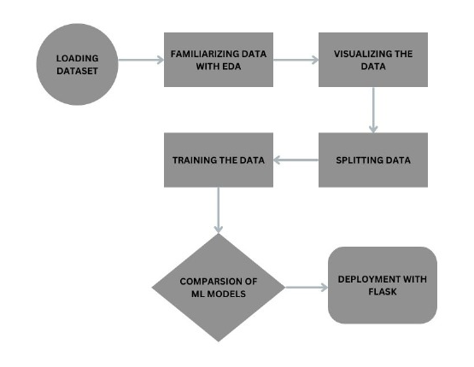

**4.1. Flow Chart**

The flowchart you sent me appears to show a general process for data analysis, not specifically for phishing site detection using machine learning algorithms. Here's a breakdown of the steps:

**1. Load data:** This involves acquiring the data you want to analyze, which could be from a variety of sources such as databases, text files, or APIs.

**2. Familiarize data:** This step involves exploring the data to get a basic understanding of its contents. This might include looking at the data types, the distribution of values, and any missing or corrupt data.

**3. Visualize the data:** Creating visualizations can help you identify patterns and trends in the data that might not be obvious from looking at the raw data.

**4. Develop the data:** This is where you prepare the data for analysis by cleaning it, transforming it into the format you need, and handling any missing or corrupt data.

**5. Train the data:** This step involves using the prepared data to train a machine learning model. The model will learn to identify patterns in the data that can be used to make predictions.

**6. Split data:** This involves dividing the data into two sets: a training set and a testing set. The training set is used to train the model, while the testing set is used to evaluate the model's performance.

**7. Comparison of ML models:** This step involves comparing the performance of different machine learning models on the testing set. The best performing model will be chosen for deployment.

**8. Deployment with Flask:** Deploying a Flask application involves several key steps to ensure a smooth and secure experience for users. Begin by preparing the application for production, optimizing dependencies, and configuring files appropriately. Next, choose a deployment method based on preferences and configure the selected hosting solution. Upload the code and dependencies to the chosen platform, and configure databases, environment variables, and security settings.

Testing the application thoroughly in a production environment and implementing monitoring tools for performance tracking and error detection are crucial steps. Explore resources like Flask deployment documentation, Heroku, Render, and Google App Engine for additional guidance.

In conclusion, deploying a Flask application is an exciting step, and by understanding options, considering needs, and following best practices, you can ensure a smooth and secure experience for users. Continuous learning and experimentation are essential for mastering successful Flask deployments.

Flask Deployment Documentation, Heroku, Render, and Google App Engine are valuable resources for detailed information on Flask deployment

**4.3 DataSet Description**

The dataset for the "Phishing Website Detection Machine Learning Models" project serves as the cornerstone for developing and training models capable of distinguishing between genuine and phishing URLs. Comprising approximately 11056 entries, this CSV file encapsulates a diverse array of URLs, each annotated with its corresponding label indicating authenticity. The richness of this dataset allows for a thorough exploration of features that are indicative of phishing behavior, paving the way for the creation of robust and effective machine learning models.

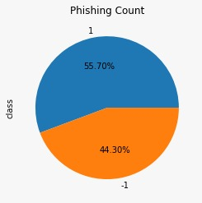

**Fig 4.1-Class of Sites**

**Dataset Structure:**

The dataset follows a structured format, with each row representing a unique URL. Two primary columns are present:

**i)URLs:**This column contains the URLs under consideration. URLs serve as the focal point for analysis, and their characteristics are crucial in identifying patterns indicative of phishing attempts.

**ii)Labels:**The 'Labels' column classifies each URL as either 'genuine' or 'phishing.' This binary classification is fundamental for the supervised learning approach that the machine learning models will undertake.

**iii)Data Distribution:**The dataset maintains a balanced distribution between genuine and phishing URLs, ensuring that the models are exposed to a representative sample of both classes. This balance is critical for preventing bias in model training, allowing the algorithms to learn and generalize effectively across both genuine and phishing scenarios.

**iv)Features and Feature Engineering:**To empower machine learning models to make accurate predictions, feature engineering plays a pivotal role. In the context of this dataset, features may include:

* URL Length
* Domain Information
* HTTP/HTTPS Protocol
* Presence of Special Characters
* IP Address Usage



**Fig 4.2 – Dataset Containing Phishing Sites**

**Data Preprocessing:** Before feeding the data into machine learning models, thorough preprocessing is essential. This includes handling missing values, standardizing formats, and converting textual data into numerical representations suitable for model training.

**Expected Impact:**The dataset serves as a catalyst for developing models that can contribute significantly to online security. By learning from a diverse set of both genuine and phishing URLs, the machine learning models aim to discern subtle patterns and characteristics that differentiate between legitimate and malicious online entities.

This project not only enhances the technical skills of a Computer Science student but also addresses a real-world challenge, emphasizing the practical application of machine learning in the realm of cybersecurity. The dataset's richness and diversity lay the foundation for creating models that can make meaningful contributions to the ongoing efforts to combat phishing threats on the internet.

**CHAPTER 5 REQUIREMENTS**

**1. Software Requirements:**

* 1. **Development Environment:**
* **Python 3.x:** The project will be implemented using Python programming language.
* **Integrated Development Environment (IDE):** Use an IDE such as Google Colab or Jupyter Notebook for coding and experimentation.
  1. **Libraries and Frameworks:**
* **Scikit-learn:** Utilize Scikit-learn for machine learning algorithms and model evaluation.
* **Pandas:** Use Pandas for data manipulation and preprocessing tasks.
* **NumPy:** Employ NumPy for numerical operations and array handling.
* **Matplotlib and Seaborn:** Use these libraries for data visualization during exploratory data analysis.
* **Flask or FastAPI:** For creating a web service to deploy the trained model.
  1. **Machine Learning Models:**

i)Logistic Regression

ii)k-Nearest Neighbors

iii)Support Vector Classifier

iv)Naive Bayes

v)Decision Tree

vi)Random Forest

vii)Gradient Boosting

viii)Catboost

ix)Xgboost

x)Multilayer Perceptrons

**1.4 Database:**SQLite or any lightweight database for storing and managing additional project-related data.

**1.5 Version Control:**

**Git:** Use Git for version control to track changes and collaborate with team members.

**2. Functional Requirements:**

**2.1 Data Collection and Preprocessing:** The system must be able to import the dataset, which includes URLs labeled as genuine or phishing. Implement data preprocessing steps to handle missing values, standardize formats, and convert textual data into numerical representations.

**2.2 Feature Engineering:** Extract and engineer features from URLs to enhance the discriminatory power of the models. Include features such as URL length, domain information, HTTP/HTTPS protocol, presence of special characters, and IP address usage.

**2.3 Model Training:** Implement machine learning models, such as decision trees, random forests, and support vector machines, for initial training. Optionally, implement deep learning models using neural networks for more complex feature learning.

Explore ensemble methods for model combination and improved performance.

**2.4 Model Evaluation:** Evaluate models using metrics such as accuracy, precision, recall, F1-score, and ROC-AUC.Perform cross-validation to ensure robustness.

**2.5 Web Service for Model Deployment:**Develop a web service using Flask or FastAPI to deploy the trained model.The service should accept URLs as input and return predictions for their authenticity.

**3. NON-FUNCTIONAL REQUIREMENTS:**

**3.1 Performance:**The system should provide timely responses when making predictions. The trained model's inference time should be optimized for real-time detection.

**3.2 Scalability:** The web service should be scalable to handle an increasing number of requests as the user base grows.

**3.3 Usability:** The user interface (if applicable) should be intuitive, providing clear instructions on how to input URLs for analysis.

**3.4 Security:** Implement secure coding practices to prevent vulnerabilities. Ensure that user data and model predictions are handled with confidentiality.

**3.5 Reliability:** The system should be reliable and available for use with minimal downtime.Implement error handling mechanisms to gracefully manage unexpected issues.

**3.6 Portability:** The system should be compatible with different operating systems and environments.

**3.7 Maintainability:** Code should be well-documented and adhere to coding standards. Include comments for better understanding and future maintenance. This comprehensive set of software, functional, and non-functional requirements outlines the necessary components and characteristics for successfully developing a Phishing Website Detection System using machine learning models.

**CHAPTER 6 METHODOLOGY**

**Methodology for Phishing Site Detection:**

While your proposed flowchart with the six steps is a solid foundation, here's an alternative methodology incorporating additional considerations and potential optimizations:

**1. Initial Exploration and Goal Setting:** Research & Problem Definition: Understand the specific problem you're addressing, define target audience, and gather existing research for reference. [Image depicting research icons and arrows pointing towards a clear problem statement] Analyze existing datasets, consider crawling techniques, and evaluate resource allocation for data acquisition. [Image showing different data sources like datasets, crawling, and APIs converging into a central data pool]

**2. Data Cleaning and Preprocessing:** Data Loading and Integration: Combine data sources, handle missing values, and ensure consistent formatting. [Image representing various data formats being merged and standardized]

**Feature Engineering:** Identify relevant features, perform data transformations, and handle categorical variables. [Image showcasing different features being extracted and processed from raw data]

**3. Exploratory Data Analysis (EDA) and Feature Selection:** Univariate and Bivariate Analysis: Analyze individual features and their relationships for insights and potential outliers. [Image displaying histograms, scatter plots, and boxplots for multiple features]

**Feature Importance and Dimensionality Reduction:** Identify redundant or irrelevant features to improve model performance and efficiency. [Image showing feature importance scores and a model being pruned based on those scores]

**4. Model Training and Selection:**

**Training/Validation/Testing Split:** Divide data into separate sets for training, validation, and final testing. [Image illustrating a pie chart dividing data into training, validation, and testing segments]

**Hyperparameter Tuning:** Optimize model hyperparameters for best performance on the validation set. [Image depicting knobs and dials representing hyperparameters being adjusted]

**Model Comparison and Selection:** Evaluate multiple models on the validation set and choose the one with the best performance measures like accuracy, precision, recall, and F1-score. [Image showing different models racing towards a finish line with performance metrics displayed as flags]

**5. Model Deployment and Monitoring:** Production Pipeline and Flask Integration, Integrate the chosen model into a production pipeline with Flask for real-time phishing detection. [Image representing data flowing through a pipeline into a Flask app]

**Model Monitoring and Retraining:** Continuously monitor performance and retrain the model with new data or updated algorithms to maintain accuracy. [Image showing a performance dashboard and arrows feeding data back into the training loop]

Early goal setting and problem definition ensure focused data acquisition and analysis.

Thorough data cleaning and feature engineering lays a strong foundation for accurate models.

Feature selection improves model efficiency and interpretability.

Model comparison and selection ensure optimal performance.

Continuous monitoring and retraining keep the model adaptive to changing trends.

**CHAPTER 7 EXPERIMENTATION**

Experimentation in the project "Phishing Site Detection using Machine Learning Algorithms" is a crucial phase aimed at fine-tuning the models, assessing their performance, and ensuring the robustness of the entire system. The experimental process encompasses several key steps, each designed to enhance the accuracy and reliability of the phishing detection system.

**1. Algorithm Selection and Comparison:**

* Train and evaluate multiple machine learning algorithms: Train the chosen algorithms (e.g., Decision Trees, SVM, Random Forest) on a designated portion of your dataset. Measure their performance on another unseen portion using metrics like accuracy, precision, recall, and F1-score. Analyze which algorithm yields the best results on your specific data.
* Test against benchmark models: Compare your best-performing model against established phishing detection algorithms available in libraries or research papers. This allows you to situate your model's performance within the broader context of phishing detection approaches.

**2. Feature Engineering and Selection:**

* Evaluate the impact of different features: Experiment with incorporating or removing specific features from your dataset. Observe how each change affects the model's performance. This helps identify the most valuable features for accurate phishing detection.
* Test feature transformation techniques: Explore different techniques for scaling, normalizing, or encoding your features. Analyze how these transformations influence the model's learning and accuracy.

**3. Hyperparameter Tuning:**

* Optimize hyperparameters of your chosen algorithm: Each algorithm has parameters that control its training process and behavior. Fine-tune these hyperparameters (e.g., number of trees in a Random Forest) using techniques like grid search or random search to achieve optimal performance.

**4. Cross-validation Techniques:**

* K-Fold Cross-validation: Divide your data into K equally-sized folds. Train the model on K-1 folds and test on the remaining fold. Repeat this process for all K folds and average the results. This provides a robust estimate of the model's generalizability and reduces the impact of randomness in the data.
* Stratified Cross-validation: If your data contains imbalance between phishing and legitimate websites, perform stratified cross-validation. This ensures each fold maintains the same proportion of classes as the original dataset, leading to a more reliable evaluation.

**5. Real-world Testing:**

* Deploy a prototype system: Develop a minimal version of your system that incorporates the best-performing model and features. Test it on a small set of real-world phishing and legitimate websites to assess its effectiveness in practical scenarios.
* Analyze user feedback: If applicable, involve users in testing your prototype system. Gather their feedback on the detection accuracy, usability, and potential false positives/negatives. This can guide further refinement of your system.

Remember to document all your experiments thoroughly, including the methods used, data splits, parameter settings, and performance metrics achieved. This allows for comprehensive analysis of your findings and informs future improvement of the model.

By conducting these experiments, you gain valuable insights into the strengths and limitations of your phishing detection system. This knowledge can be used to refine your model, address its weaknesses, and ultimately build a more robust and effective tool for protecting users from online scams

**CHAPTER 8 RESULTS AND DISCUSSION**

We have used different ML Algorithms to train the model and in each model we got different results ,the below table shows the comparison between the models that we have used

|  |  |  |  |  |
| --- | --- | --- | --- | --- |
| **MODELS** | **ACCURACY** | **F1_SCORE** | **RECALL** | **PRECISION** |
| logestic regression | 0.934 | 0.941 | 0.953 | 0.930 |
| k–Nearest neighbor | 0.956 | 0.961 | 0.962 | 0.960 |
| svm | 0.964 | 0.968 | 0.980 | 0.957 |
| naïve bayes | 0.605 | 0.54 | 0.294 | 0.995 |
| decision tree | 0.961 | 0.965 | 0.964 | 0.966 |
| random forest | 0.967 | 0.970 | 0.972 | 0.966 |
| gradient boosting | 0.974 | 0.977 | 0.989 | 0.966 |
| catboost | 0.911 | 0.975 | 0.982 | 0.969 |
| xgboost | 0.969 | 0.973 | 0.993 | 0.984 |
| multilayer  perceptron | 0.954 | 0.980 | 0.967 | 0.923 |

**Fig 8.1-figure showing results of different models**

The provided data appears to be a performance summary of various machine learning models on a classification task. each row in the table represents a different machine learning model, and the columns contain metrics that evaluate the model's performance.

Here's a brief description of each metric:

**1. Models:** the names of the machine learning models considered in the evaluation.

**2. Accuracy**: the proportion of correctly classified instances out of the total instances. it provides a general measure of the model's correctness.

**3.F1 score:** the harmonic mean of precision and recall. it is a metric that balances both false positives and false negatives, making it useful when there is an uneven class distribution.

**4. Recall (sensitivity):** the ability of the model to correctly identify all relevant instances. it is the ratio of true positives to the sum of true positives and false negatives.

**5. Precision:** the ability of the model to correctly identify only the relevant instances among all instances predicted as positive. it is the ratio of true positives to the sum of true positives and false positives.

Now, let's interpret the provided data:

**Logistic Regression:** high accuracy (93.4%) and good performance across other metrics.

**k–nearest neighbor (KNN):** very high accuracy (95.6%) with strong f1 score, recall, and precision.

**Support Vector Machine (SVM):** excellent performance with high accuracy (96.4%) and balanced f1 score, recall, and precision.

**Naive Bayes:** lower accuracy (60.5%) and f1 score, with significantly lower recall. high precision indicates a low rate of false positives.

**Decision Tree:** high accuracy (96.1%) and strong performance in f1 score, recall, and precision.

**Random forest**: similar to decision tree, with slightly higher accuracy (96.7%).

**Gradient Boosting**: high accuracy (97.4%) and strong performance in f1 score, recall, and precision.

**Catboost:** good accuracy (91.1%) with high f1 score, recall, and precision.

**XGBOOST:** high accuracy (96.9%) and excellent performance in f1 score, recall, and precision.

**MultiLayer Perceptron (MLP**): high accuracy (95.4%) with the highest f1 score, recall, and precision among all models.

From the above result, we infer that XGBOOST is the best model among all the other ml models

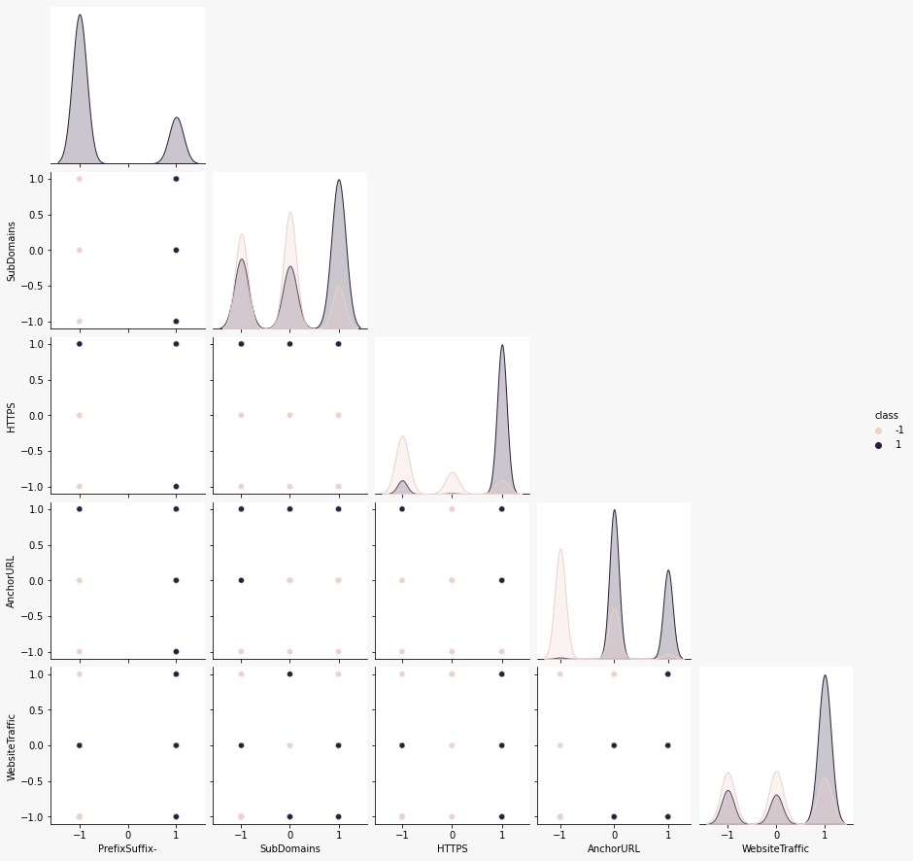

**Fig 8.1 – PairPlot of particular Features**

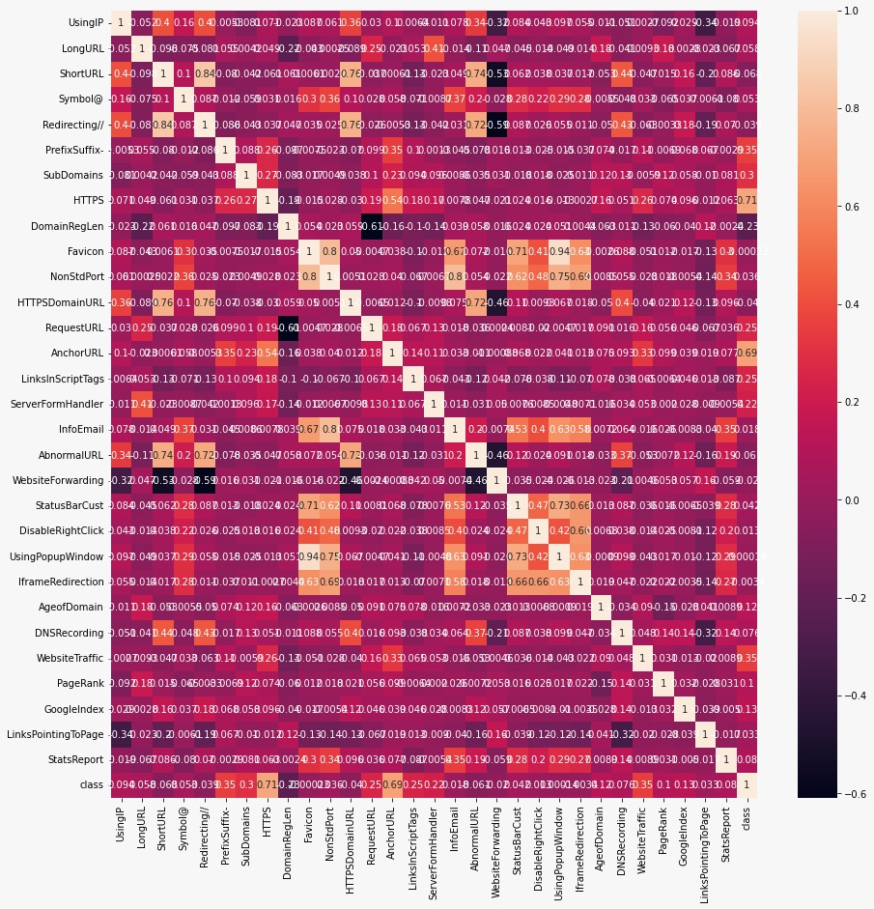

**Fig 8.2-Correlation HeatMap**

The heatmap you sent me displays the correlation between 31 features used to identify phishing websites. Each feature is represented by a square on the grid, and the color of the square represents the strength and direction of its correlation with other features. These are just some of the interesting observations from the heatmap. By analyzing the correlations between different features, researchers can gain valuable insights into the characteristics of phishing websites and develop more effective detection methods.

It's important to note that this heatmap is just one part of a larger study on phishing website detection

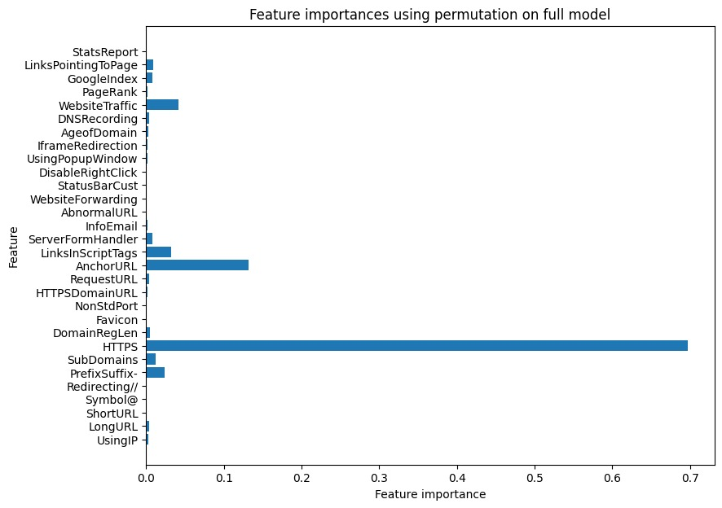

**Fig 8.3 – Feature Importance**

The most important feature for identifying phishing websites appears to be “LinksPointingToPage”, "StatsReport" and "GoogleIndex". This suggests that websites with many incoming links, suspicious website statistics, and lack of Google indexing are more likely to be phishing attempts. Overall, this feature importance graph provides valuable insights into the characteristics that machine learning algorithms might prioritize when identifying phishing websites.

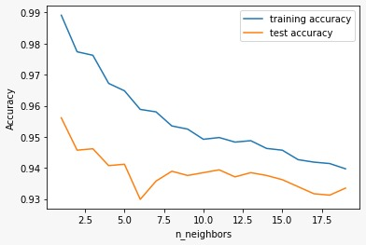

**Fig 8.4 - K – Nearest Neighbor**

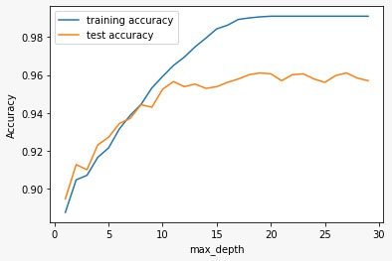

**Fig 8.5 – Decision Tree**

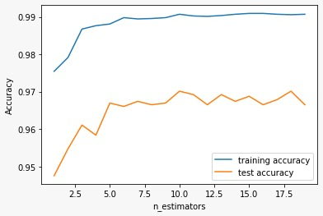

**Fig 8.6 – Random Forest**

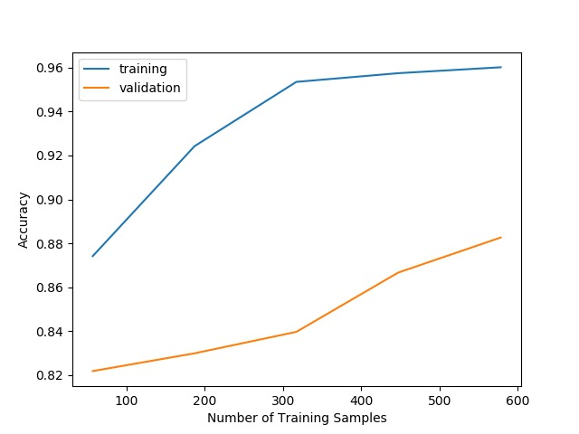

**Fig 8.7 - XGBOOST**

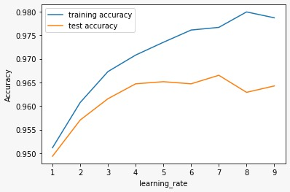

**Fig 8.8 – Gradient Boost**

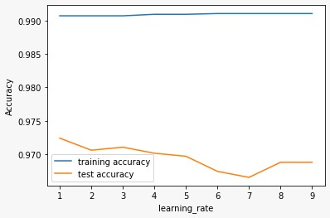

**Fig 8.9 - CatBoost**

**OUTPUT**

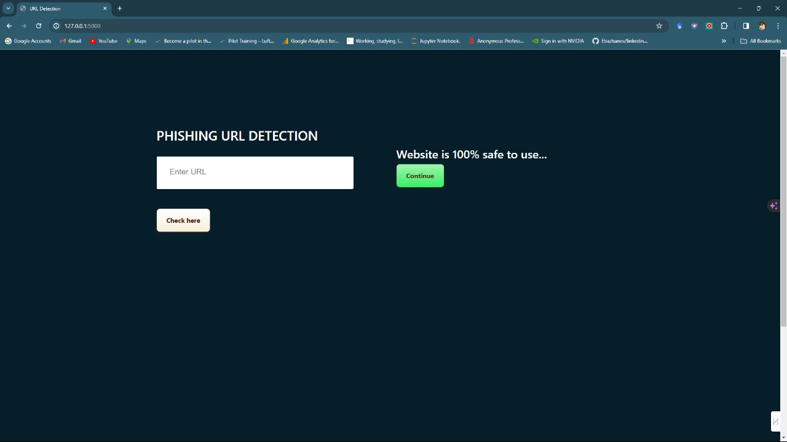

**Fig 8.10 Detection of Legitimate site**

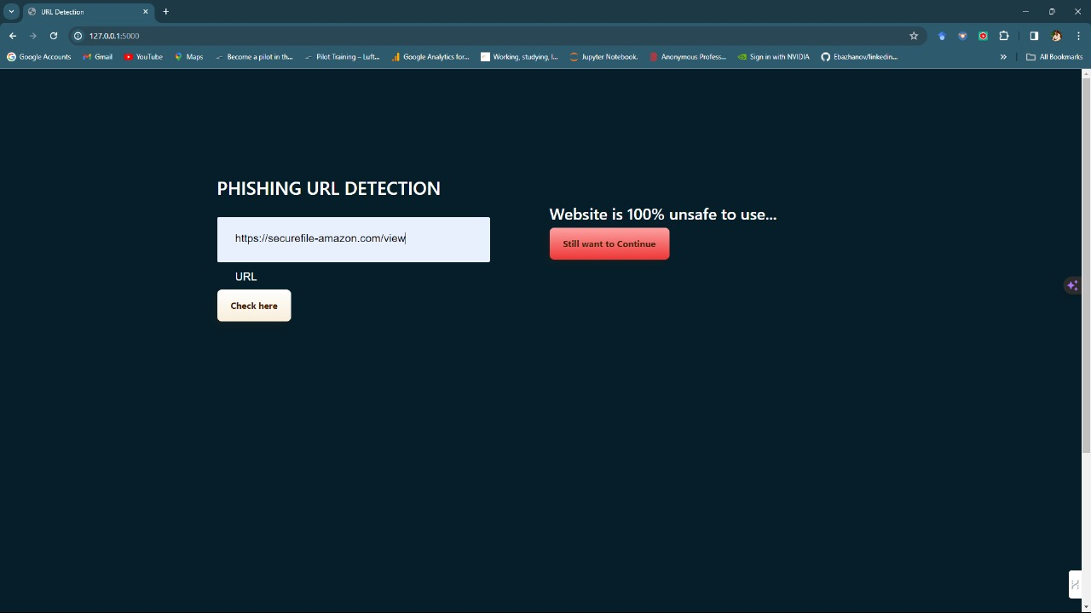

**Fig 8.11 Detection of Phishing Site**

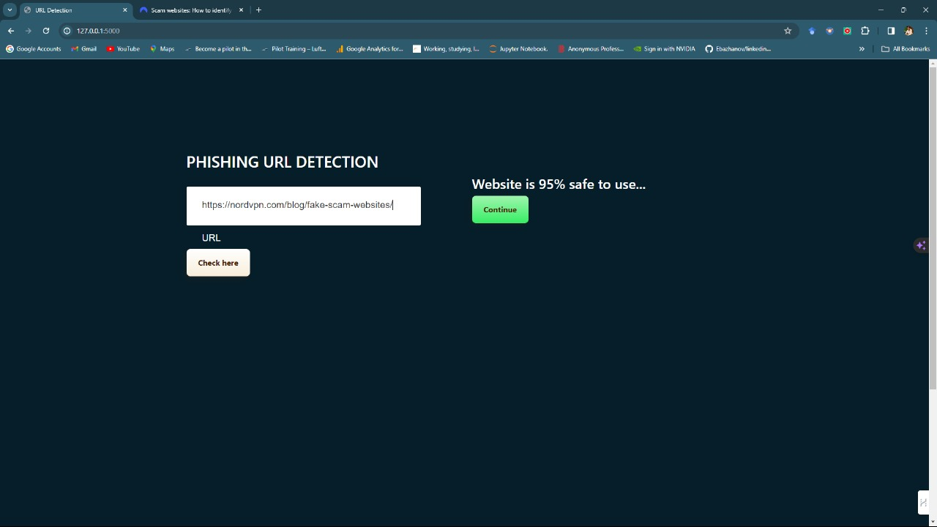

**Fig 8.12 Phishing URL detection**

**CHAPTER 9 CONCLUSION**

In conclusion, the performance evaluation of various machine learning models on the classification task reveals notable differences in their effectiveness. Each model exhibits strengths and weaknesses across different metrics, emphasizing the importance of considering specific requirements and trade-offs in choosing the most suitable model for a given application.

We have concluded that XGBoost (Extreme Gradient Boosting) is often considered effective for detecting phishing websites due to its ensemble learning approach, which combines the strengths of multiple weak learners (usually decision trees) to create a robust and accurate predictive model. Here are some reasons why XGBoost might be well-suited for detecting phishing websites:

**Handling Imbalanced Data**: Phishing detection tasks often involve imbalanced datasets, where the number of legitimate websites significantly outweighs the number of phishing websites. XGBoost can handle imbalanced data well, as it includes regularization terms in its objective function that penalizes misclassifying the minority class.

**Ensemble Learning**: XGBoost is an ensemble learning algorithm, meaning it combines the predictions of multiple weak learners to create a strong learner. This ensemble approach improves the model's generalization and makes it less prone to overfitting, which is crucial for accurately classifying phishing websites.

**Tree Pruning and Regularization**: XGBoost employs techniques such as tree pruning and regularization to control the complexity of individual decision trees in the ensemble. This helps prevent overfitting and enhances the model's ability to generalize well to unseen data.

XGBoost is widely used, well-maintained, and has robust implementations in various programming languages. Its scalability makes it suitable for handling large datasets, which is essential for effective phishing detection across a diverse range of websites.

**REFERENCES**

[1] Wenqian Tian; Pei Li; Tao Wei; Zhenkai Liang "Phishing-Alarm: Robust and Efficient Phishing Detection via Page Component Similarity" 17020 - 17030, 23 August 2017

[2] B. Deekshitha, Ch. Aswitha, Ch. Shyam Sundar, A. Kavya Deepthi "URL Based Phishing Website Detection by Using Gradient and Catboost Algorithms "IJRASET, Volume 10, June 2022.

[3] Ammar Odeh, Abdalraouf Alarbi, Ismail Keshta, "efficient prediction of phishing websites using multilayer perceptron (mlp) '', journal of Theoretical and applied information technology,31st August 2020. vol.98.

[4] Luka Jovanovic, Dijana Jovanovic, Milos Antonijevic," Improving Phishing Website Detection Using a Hybrid Two-level Framework for Feature Selection and XGBoost Tuning", Journal of Web Engineering, Vol. 22 3, 18 April 2023.

[5] Rishikesh Mahajan, Irffan Siddavatam, "Phishing Website Detection using Machine Learning Algorithms ", International Journal of Computer Applications (0975 – 8887)

Volume 181 – No. 23, October 2018